ECP Project Proposal

Guitar Distortion Pedal
Daksh Khandelwal & Ali Albayati
Section 201

We are setting out to build a distortion effect pedal circuit for electric guitars. Most electric guitars by themselves are passive circuits. They output sound by detecting changes in magnetic flux with the strings; this system will take this as input and provide a way of mixing the audio. The idea is to create a custom overdrive/distortion pedal used for guitars and audio signals. The overdrive uses "soft clipping" on the audio signal which becomes sensitive to touch and changes to the guitar, it adds a sense of warmth to the audio making it good for blues and classic rock. The soft clipping will be implemented in the feedback loop of the op-amp with the use of diodes, exploiting their threshold voltage to round off the edges of the signal.
The distortion effect is done with "hard clipping" the signal, which flattens the edges, this is less sensitive and makes the tone sound a bit thicker consistently. This makes the audio more suitable for something like metal and punk sound. Visualizing the clipping, soft clipping rounds the waves a little downwards while hard clipping flattens the peaks into a square wave. This hard clipping is again done with diodes in parallel to the signal path, connected to ground which cuts off the voltage when it goes above the diodes threshold voltage. In the system, low-pass filtering will is used to remove high frequency effects in the output which came from the clipping, and high-pass filtering is used in order to control lower frequencies in the input before distortion.

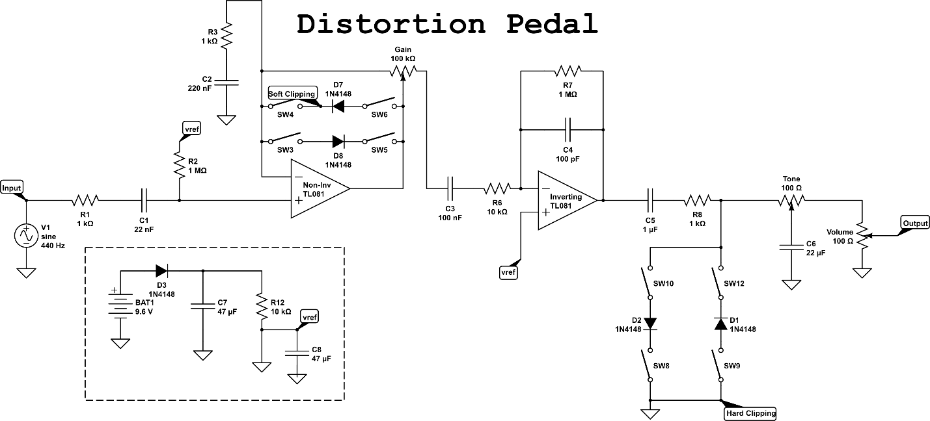
Above is the circuit for our distortion pedal. The input is the raw signal from the guitar. The signal travels through a high-pass filter (formed by the $1 \text{k}Ω$ input resistor and $22 nF$ coupling capacitor) which blocks any unwanted DC offset and allows the AC audio signal to pass. The signal is then biased to a $4.5 V$ reference voltage ($V_{ref}$) so the AC waveform can swing symmetrically within the op-amp's single-supply power constraints.
From there, it enters the first op-amp stage through a non-inverting configuration, which amplifies the signal based on the setting of the Gain potentiometer. The feedback loop of this amplifier contains a pair of anti-parallel diodes (D7 and D8) that can be engaged via switches to create soft clipping. This gently rounds off the peaks of the audio waveform, resulting in a smoother, natural-sounding overdrive.

The signal then passes through another coupling capacitor to remove any DC offset before entering a second op-amp in inverting configuration. This stage utilizes a $100 pF$ capacitor in its feedback loop to act as an active low-pass filter, taming any harsh, high-frequency harmonics introduced by the previous gain stage.
Immediately following this second amplifier, the signal encounters another pair of anti-parallel diodes (D1 and D2) that are shunted directly to ground. When engaged, these diodes create hard clipping, aggressively chopping off the peaks of the waveform entirely to produce a heavier, grittier distortion. Finally, the distorted signal travels through a passive, adjustable RC low-pass filter (the Tone control) to shape the final EQ, and a Volume potentiometer that acts as a voltage divider to set the overall output level of the pedal."

PLAN B: The alternative is to create a circuit where it performs the first statement of the Fundamental Theorem of Calculus, where the derivative of an integrated function will return the original function. It will start by using an integrator circuit, and having its output connected to the input of a differentiator circuit, after this operation, the original voltage signal should be returned.

